Problem 01 VLAN Configuration (Cisco Packet Tracer)

VLAN (Virtual Local Area Network) is a technology that allows you to divide one physical network into multiple logical networks.

Topology Setup
- 1 Switch (e.g., Cisco 2960 Switch)
- 2–4 PCs
- Connect PCs to switch using copper straight-through cable
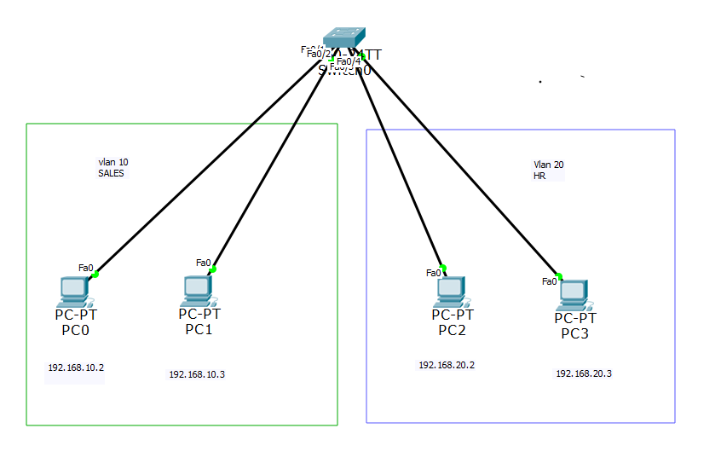
Step 1: Create VLANs
Go to Switch → CLI
enable
configure terminal
vlan 10
name SALES
exit
vlan 20
name HR
exit

Step 2: Assign Ports to VLANs
Example:
- PC0 → VLAN 10 (Fa0/1)
- PC1 → VLAN 10 (Fa0/2)
- PC2 → VLAN 20 (Fa0/3)
- PC3 → VLAN 20 (Fa0/4)
interface fastEthernet 0/1
switchport mode access
switchport access vlan 10
exit
interface fastEthernet 0/2
switchport mode access
switchport access vlan 10
exit
interface fastEthernet 0/3
switchport mode access
switchport access vlan 20
exit
interface fastEthernet 0/4
switchport mode access
switchport access vlan 20
exit

Step 3: Assign IP Addresses to PCs
VLAN 10:
- IP: 192.168.10.2, 192.168.10.3
- Subnet: 255.255.255.0

VLAN 20:
- IP: 192.168.20.2, 192.168.20.3
- Subnet: 255.255.255.0

Step 4: Verify VLAN

show vlan brief
You should see VLAN 10 & VLAN 20 with assigned ports.
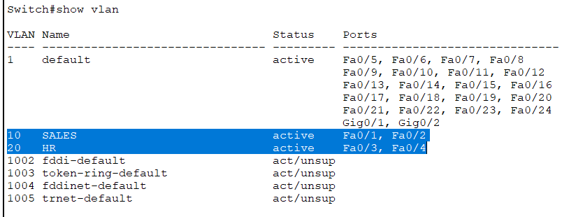
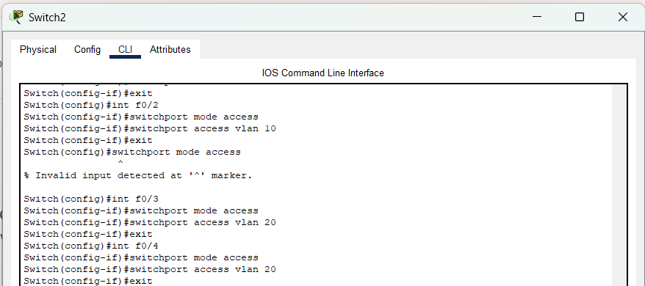

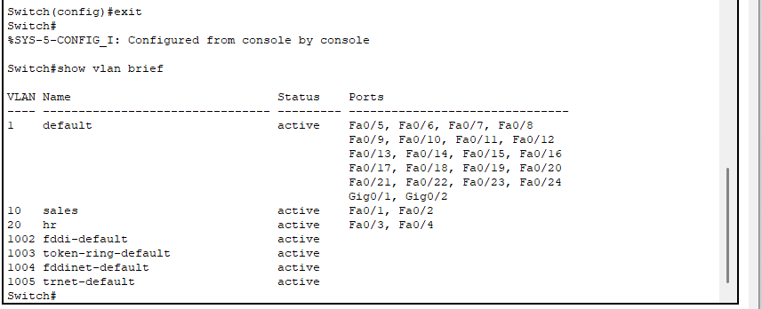

Inter-VLAN Routing configuration
Inter-VLAN routing is the process of allowing communication between different VLANs

VLAN Configuration with Layer 3 Switch and Router
This experiment shows the way of configuring a VLAN switch under a router. During configuring a switch each interface is assigned under a VLAN (VLAN has both name and number) where the interface of a switch is referred to a port number. The router has to be configured such that each set of IP address (for a VLAN) is referred to a port number or interface of the router. Every port of the switch towards the PCs are in access mode where the port or interface of the switch towards the router is in trunking mode. During packet delivery, the router encapsulates a packet under IEEE 802.1q protocol where IEEE 802.1q header is added with each frame using the command ‘encapsulation dot1q’ and sends it to the appropriate port number.

Problem 02
Step-1
Draw the network like below.
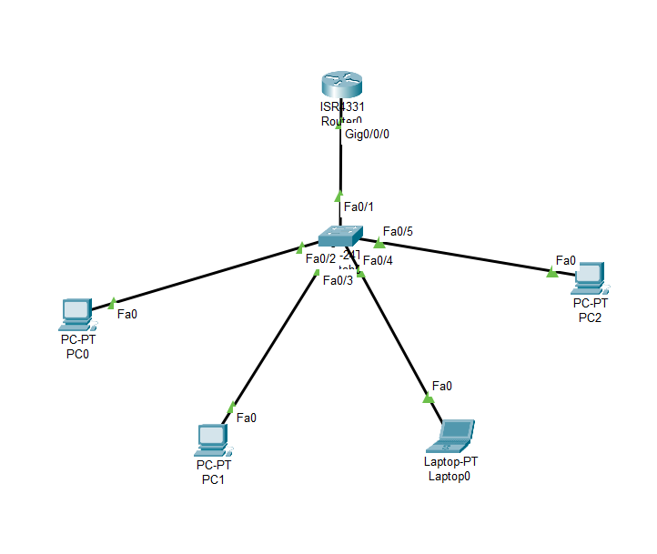
Step-2
Configure PC-0, PC-1, Laptop0, PC-2 like below.

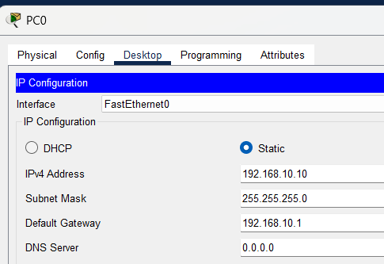
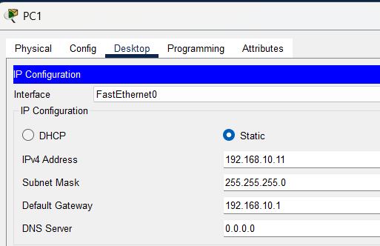
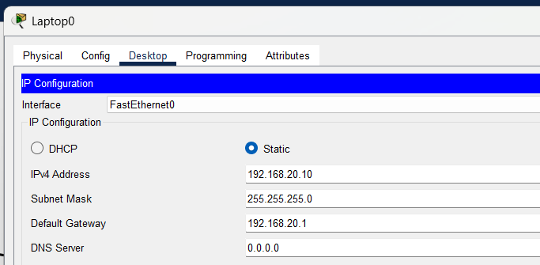

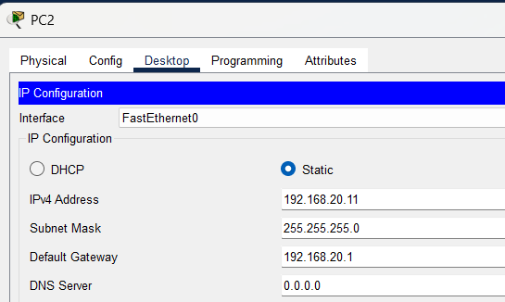

Step-3
Configure the switch like:
Switch0
Switch>enable
Switch#configure t
Enter configuration commands, one per line. End with CNTL/Z.
Switch(config)#vlan 10
Switch(config-vlan)#name A
Switch(config-vlan)# exit
Switch(config)#vlan 20
Switch(config-vlan)#name B
Switch(config-vlan)#exit
Switch(config)#interface FastEthernet0/2

Switch(config-if)#switchport mode access
Switch(config-if)#switchport access vlan 10
Switch(config-if)#exit
Switch(config)#interface FastEthernet0/2
Switch(config-if)#exit
Switch(config)#interface FastEthernet0/3
Switch(config-if)#switchport mode access
Switch(config-if)#switchport access vlan 10
Switch(config-if)#exit
Switch(config)#interface FastEthernet0/3
Switch(config-if)#exit
Switch(config)#interface FastEthernet0/4
Switch(config-if)#switchport mode access
Switch(config-if)#switchport access vlan 20
Switch(config-if)#exit
Switch(config)#interface FastEthernet0/4
Switch(config-if)#exit
Switch(config)#interface FastEthernet0/5
Switch(config-if)#switchport mode access
Switch(config-if)#switchport access vlan 20
Switch(config-if)#exit
Switch(config)#interface FastEthernet0/1
Switch(config-if)#switchport mode trunk

%LINEPROTO-5-UPDOWN: Line protocol on Interface FastEthernet0/1, changed state to down

%LINEPROTO-5-UPDOWN: Line protocol on Interface FastEthernet0/1, changed state to up

Switch(config-if)#end
Switch#
%SYS-5-CONFIG_I: Configured from console by console

Switch#

Step-4
Configure the router like:
Router#enable
Router#conf t

Enter configuration commands, one per line. End with CNTL/Z.
Router(config)#interface GigabitEthernet0/0/0
Router(config-if)#no shutdown
Router(config-if)#exit
Router(config)#interface GigabitEthernet0/0/0
Router(config-if)#exit
Router(config)#interface GigabitEthernet0/0/0
Router(config-if)#exit
Router(config)#interface GigabitEthernet0/0/0
Router(config-if)#no shutdown
Router(config)#int g0/0/0.1
Router(config-subif)#
%LINK-5-CHANGED: Interface GigabitEthernet0/0/0.1, changed state to up

%LINEPROTO-5-UPDOWN: Line protocol on Interface GigabitEthernet0/0/0.1, changed state to up

Router(config-subif)#encapsulation dot1q 1
Router(config-subif)#ip add 192.168.1.1 255.255.255.0
Router(config-subif)#int g0/0/0.2
Router(config-subif)#
%LINK-5-CHANGED: Interface GigabitEthernet0/0/0.2, changed state to up

%LINEPROTO-5-UPDOWN: Line protocol on Interface GigabitEthernet0/0/0.2, changed state to up

Router(config-subif)#encapsulation dot1q 10
Router(config-subif)#ip add 192.168.10.1 255.255.255.0
Router(config-subif)#int g0/0/0.5
Router(config-subif)#
%LINK-5-CHANGED: Interface GigabitEthernet0/0/0.5, changed state to up

%LINEPROTO-5-UPDOWN: Line protocol on Interface GigabitEthernet0/0/0.5, changed state to up

Router(config-subif)#encapsulation dot1q 20
Router(config-subif)#ip add 192.168.20.1 255.255.255.0
Router(config-subif)#end
Router#

Step-5
In switch you can observe the VLAN configuration using following command.
Switch>sh vlan brief

